Assignment 10 using pipeline
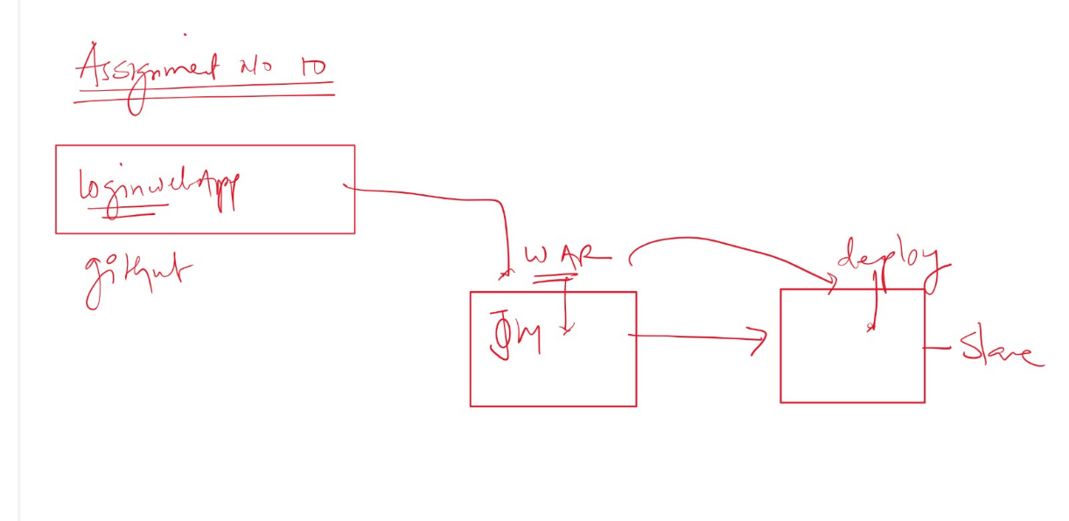
Que- create war file using git project and deploy it on slave
Ans- we can create 1 pipeline
It will create war file using git and upload that war file on s3
download war file from s3 and deploy it on slave
First launch 2 instance and connect to them
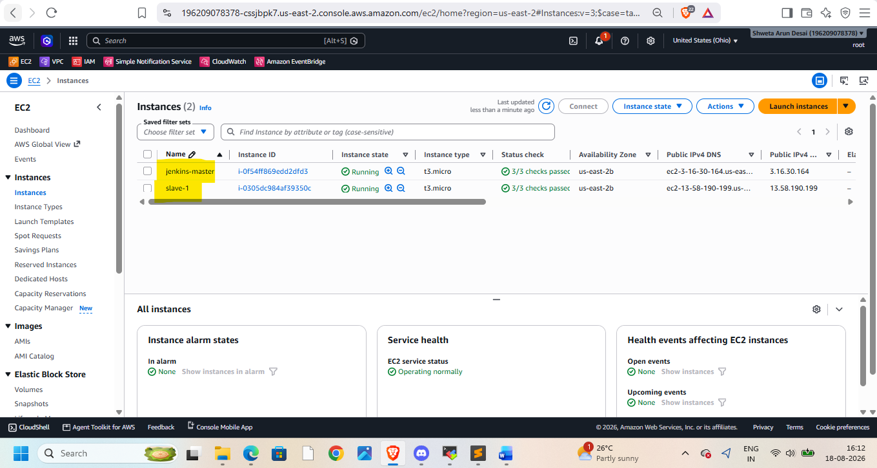
Install java,maven,git,Jenkins,tomcat on it
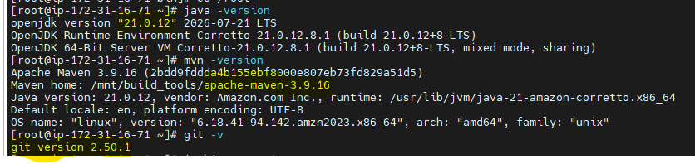
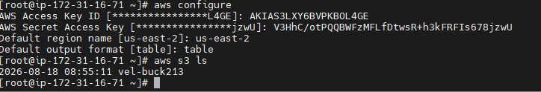
Do aws configure on both instances
Create IAM role and attach to master instance
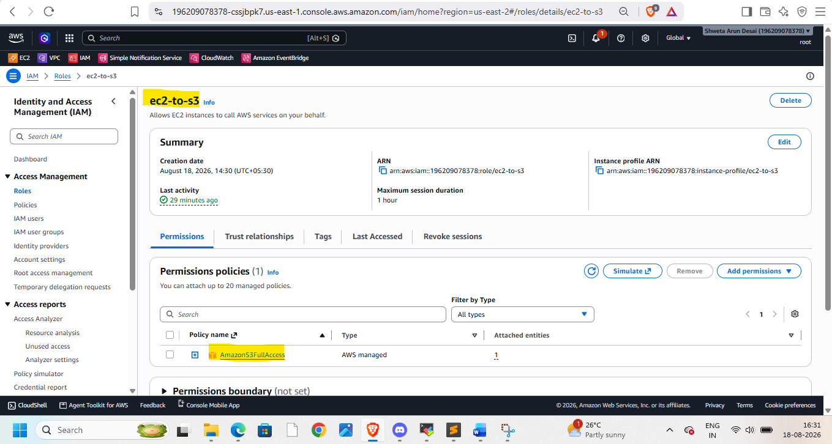
Connect to slave-1
Install java 21 ,git 2.5, tomcat10
create Jenkins-slave folder in /mnt -> workspace of slave
attach created IAM role to slave as well
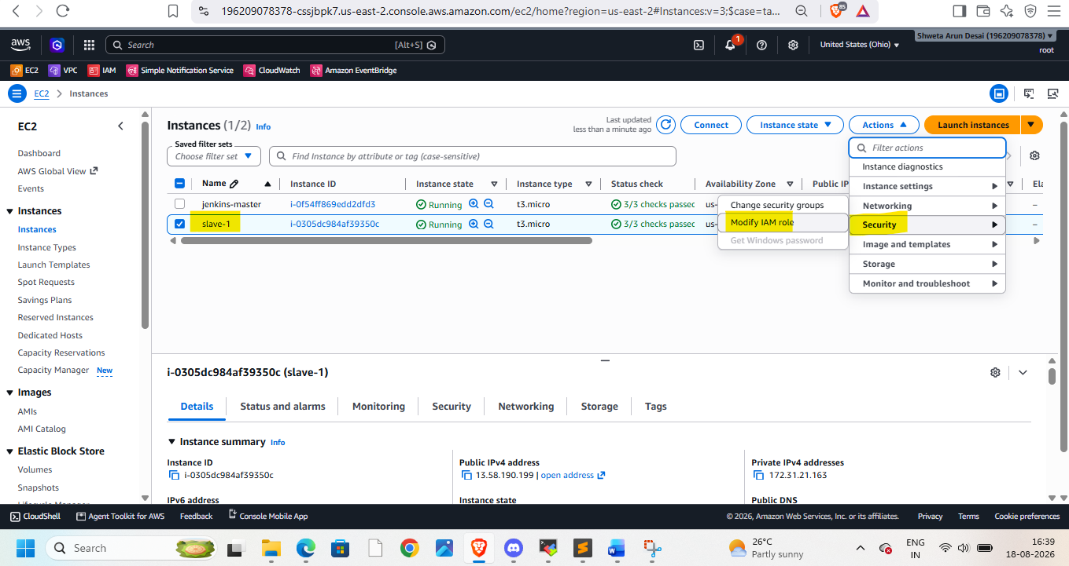
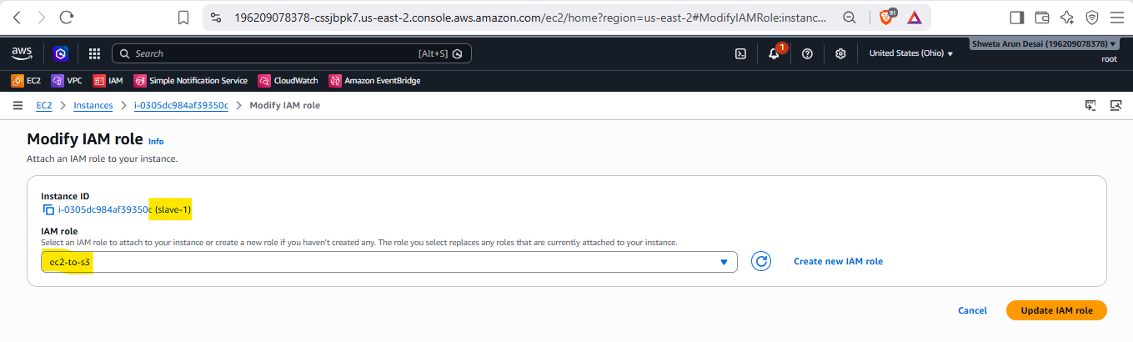Login to Jenkins
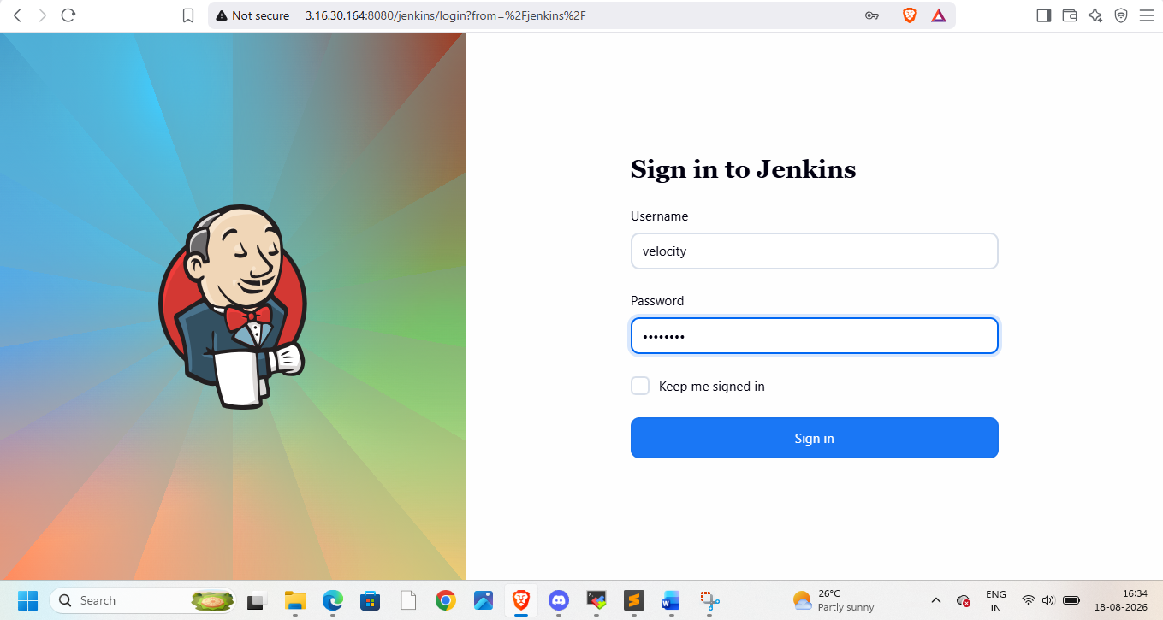
Goto manage Jenkins and node -> create node
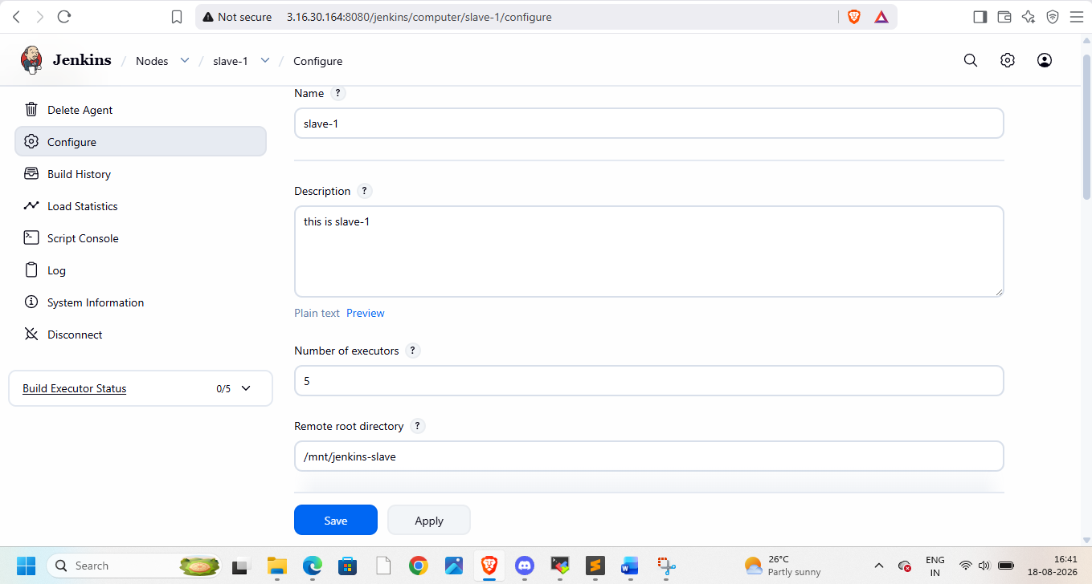
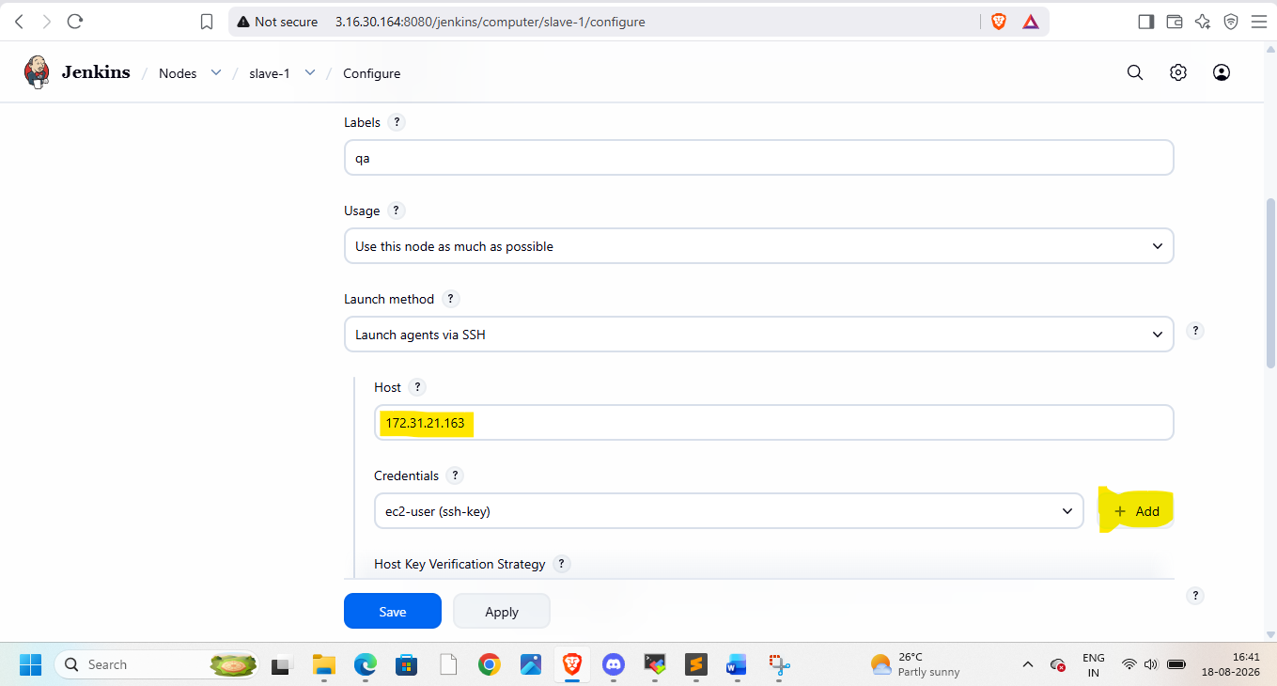add credentials, use private ip of slave-1
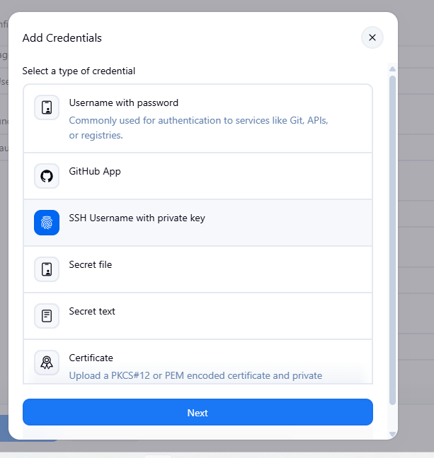
Provide pem file key with you
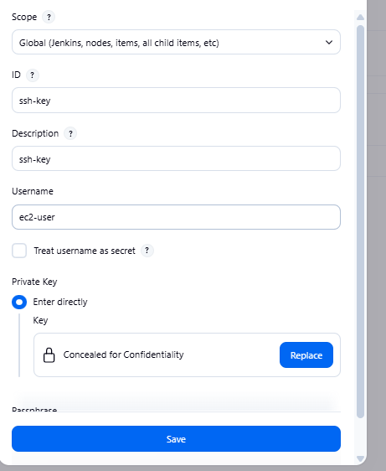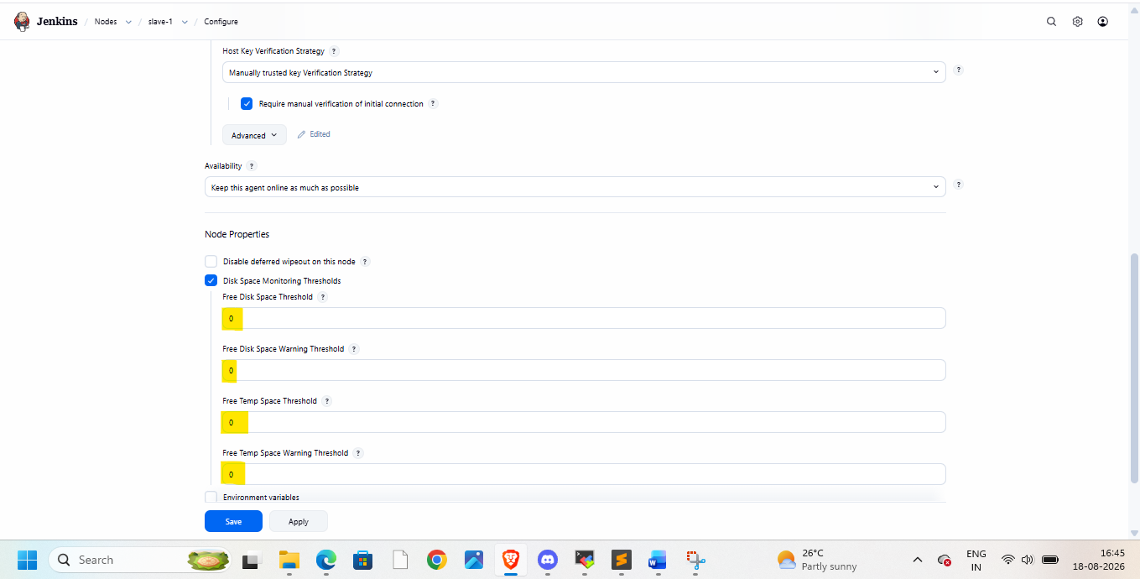
Then apply and save
As we need mvn here
Go to tools in manage jenkins and add maven details here
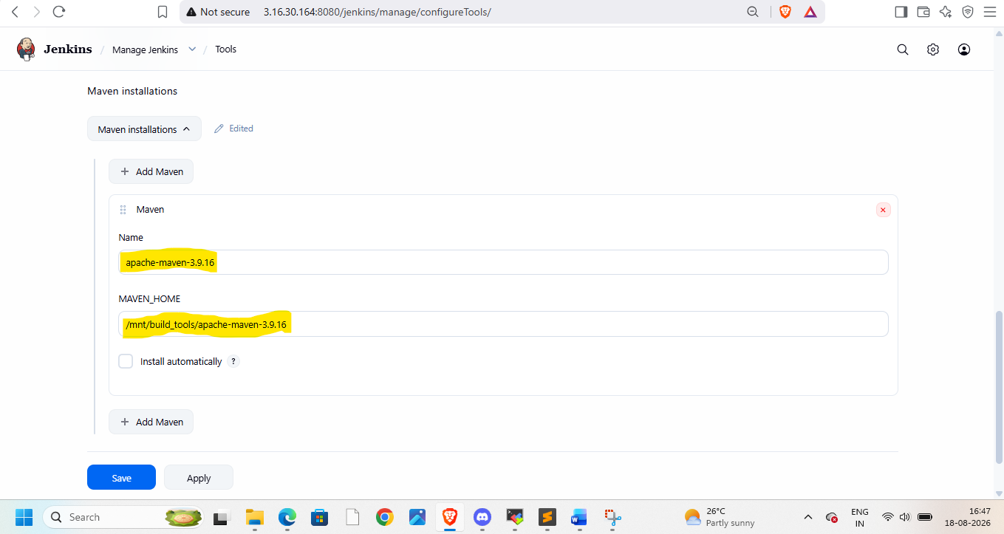
Now create pipeline
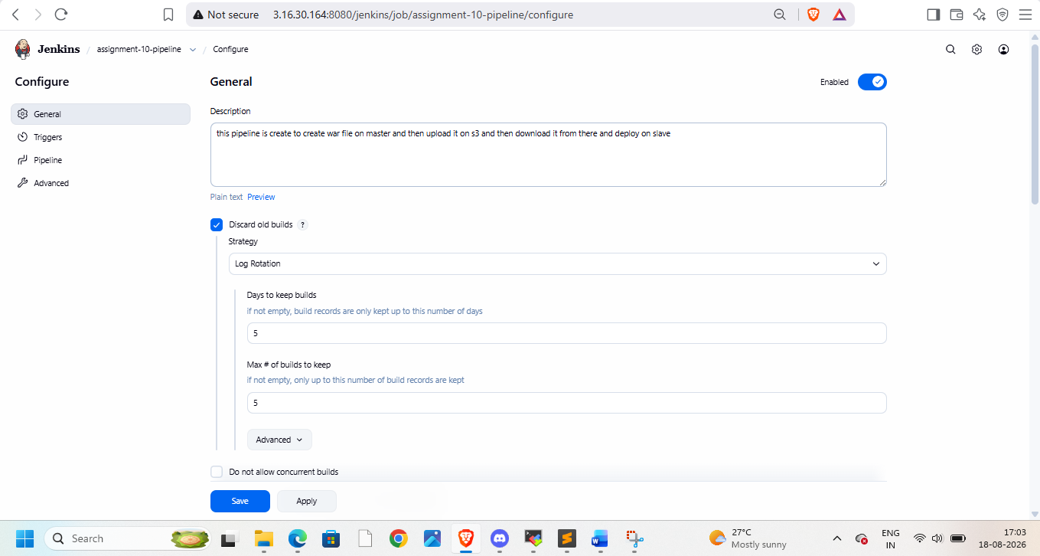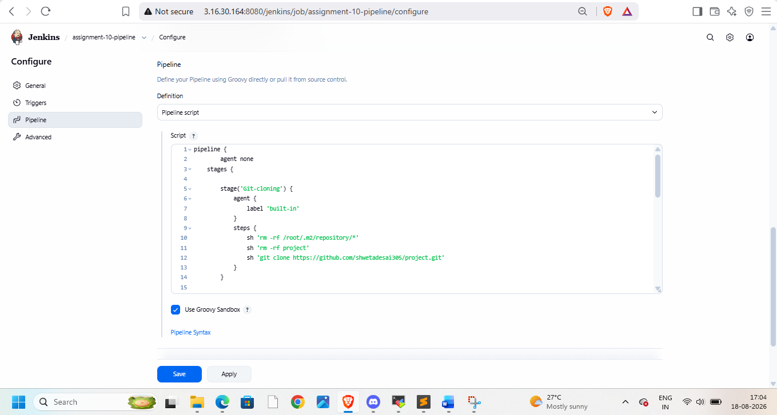
Pipeline
pipeline {
agent none
stages {

stage('Git-cloning') {
agent {
label 'built-in'
}
steps {
sh 'rm -rf /root/.m2/repository/*'
sh 'rm -rf project'
sh 'git clone https://github.com/shwetadesai305/project.git'
}
}

stage('Creating package') {
agent {
label 'built-in'
}
steps {
sh 'cd project && mvn clean package -DskipTests=true'
}
}

stage('Upload to S3') {
agent {
label 'built-in'
}
steps {
sh 'cd project && aws s3 cp target/LoginWebApp.war s3://vel-buck213/'
}
}

stage('Download from S3 to slave') {
agent {
label 'slave-1'
}
steps {
sh 'sudo chmod -R 777 /mnt/servers/apache-tomcat-10.1.57/'
sh 'rm -rf /mnt/servers/apache-tomcat-10.1.57/webapps/LoginWebApp*'
sh 'aws s3 cp s3://vel-buck213/LoginWebApp.war /mnt/servers/apache-tomcat-10.1.57/webapps/'
}
}
}
}

Then check on browser


